Treasure Warehouse
ABSTRACT:

This project is mainly developed for the Account Division of a Banking sector to provide better interface to the entire banking transactions. The system is aimed to give a better outlook to the user interfaces and to implement all the banking transactions with an efficient and secure interface between bank and customers. In this system whenever a new customer registers, this system facilitates to create an account in his name. The customer must upload their proof like voter id, driving license. After submitting all information the bank administrator verify the information. If the details given by the customer are correct the admin create a account else reject their application. The customer check their balance and can change their security pin number. The administrator deposit money to corresponding customer. The customer can transfer money to any person’s account. The customer can view statement of all transaction.

EXISTING SYSTEM:

Present systems involve lots of manual work, which may be error prone. The present system is less secure. Customers need to wait for more time as the manual mode of system is a time consuming process. Customer authentication is a time consuming process as the signatures need to be verified against existing documents (which will be generally maintained in files).

PROPOSED SYSTEM:

The proposed system automates all the following activities to implement error free, time and cost saving process. In this system whenever a new customer registers, this system facilitates to create an account in his name. The customer must upload their proof like voter id, driving license. After submitting all information the bank administrator verify the information. If the details given by the customer are correct the admin create a account else reject their application. The customer check their balance and can change their security pin number. The administrator deposit money to corresponding customer. The customer can transfer money to any person’s account. The customer can view statement of all transaction.

Administrator involved the followings:
Can verify the details of the new customer account request.
Can can create or reject new account request based on the information
given by the new customer.
Can view all customer details.
Can make deposit to corresponding customer.

Customer involved the followings
Can give new account request.
Can check balance available in their account
Can transfer the money to any account.
Can view statement about the transaction.
Can change the security pin number.

STUDY OF THE SYSTEM:
To provide flexibility to the users, the interfaces have been developed that are accessible through a browser. The GUI’S at the top level have been categorized as
- Administrative user interface
- The operational or generic user interface
The ‘administrative user interface’ concentrates on the consistent information that is practically, part of the organizational activities and which needs proper authentication for the data collection. These interfaces help the administrators with all the transactional states like Data insertion, Data deletion and Date updation along with the extensive data search capabilities.
The ‘operational or generic user interface’ helps the end users of the system in transactions through the existing data and required services. The operational userinterface also helps the ordinary users in managing their own information in a customized manner as per the included flexibilities.
FEASIBILITY REPORT:
Feasibility Report:
Preliminary investigation examines project feasibility, the likelihood the system will be useful to the organization. The main objective of the feasibility study is to test the Technical, Operational and Economical feasibility for adding new modules and debugging old running system. All systems are feasible if they are given unlimited resources and infinite time. There are aspects in the feasibility study portion of the preliminary investigation:
- Technical Feasibility
- Operation Feasibility
- Economical Feasibility
Technical Feasibility:
The technical issue usually raised during the feasibility stage of the investigation includes the following:
- Does the necessary technology exist to do what is suggested?
- Do the proposed equipments have the technical capacity to hold the data required to use the new system?
- Will the proposed system provide adequate response to inquiries, regardless of the number or location of users?
- Can the system be upgraded if developed?
- Are there technical guarantees of accuracy, reliability, ease of access and data security?

Operational Feasibility:

Proposed projects are beneficial only if they can be turned out into information systems, which will meet the organization’s operating requirements. Operational feasibility aspects of the project are to be taken as an important part of the project implementation. Some of the important issues raised are to test the operational feasibility of a project includes the following: -

- Is there sufficient support for the management from the users?
- Will the system be used and work properly if it is being developed and implemented?
- Will there be any resistance from the user that will undermine the possible application benefits?

This system is targeted to be in accordance with the above-mentioned issues. Beforehand, the management issues and user requirements have been taken into consideration. So there is no question of resistance from the users that can undermine the possible application benefits.
The well-planned design would ensure the optimal utilization of the computer resources and would help in the improvement of performance status.
Economic Feasibility:
A system can be developed technically and that will be used if installed must still be a good investment for the organization. In the economical feasibility, the development cost in creating the system is evaluated against the ultimate benefit derived from the new systems. Financial benefits must equal or exceed the costs. The system is economically feasible. It does not require any additional hardware or software.

MODULE DESCRIPTION:

Number of Modules
After careful analysis the system has been identified to have the following modules:
New Account:

Whenever a new customer registers, this system facilitates to create an account in his name. The customer must upload their proof like voter id, driving license. After submitting all information the bank administrator verify the information. If the details given by the customer are correct the admin create a account else reject their application.

Admin module:

The bank administrator view new accout request from the customers the bank administrator verify the information. If the details given by the customer are correct the admin create a account else reject their application. The bank administrator view all customer details and can download their information.

Deposit:

The admin module consists the deposit module. The money deposits made by the bank administrator to the corresponding customer. The deposit can made for customer who having the account in the same bank.

Customer Module:
The customer check their balance and can change their security pin number. The administrator deposit money to corresponding customer. The customer can transfer money to any person’s account. The customer can view statement of all transaction.

Reports:
Reports are very essential for the banking organization. It needs to generate different reports of banking information and transactions from the stored information. The can make reports of all customer details. The user can view all money transaction.

SYSTEM DESIGN:(Admin)

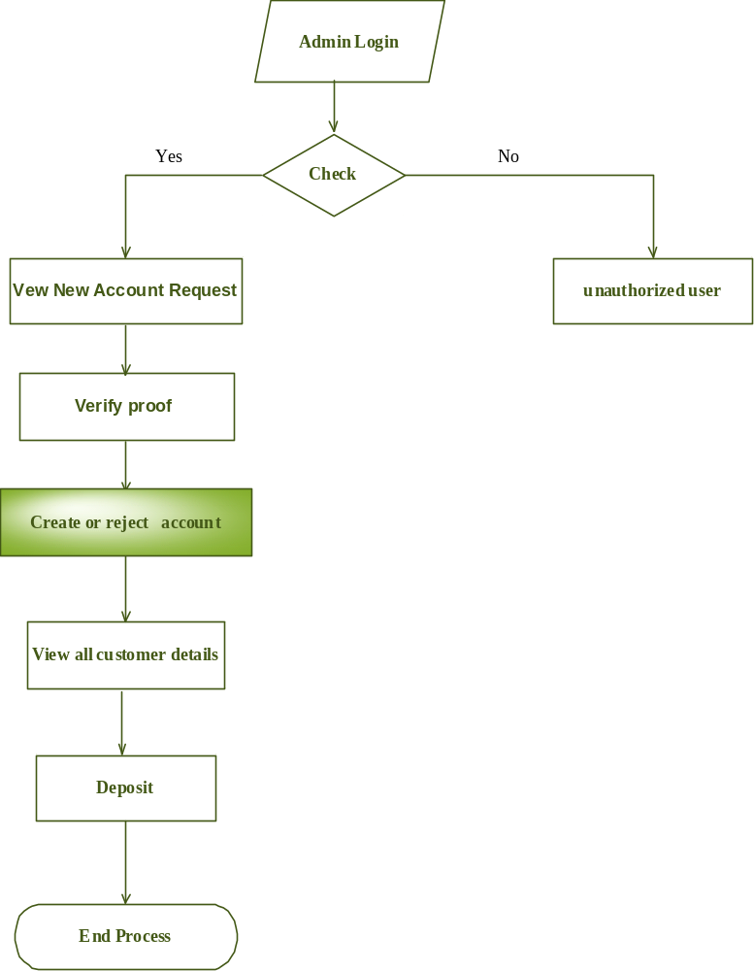

Customer
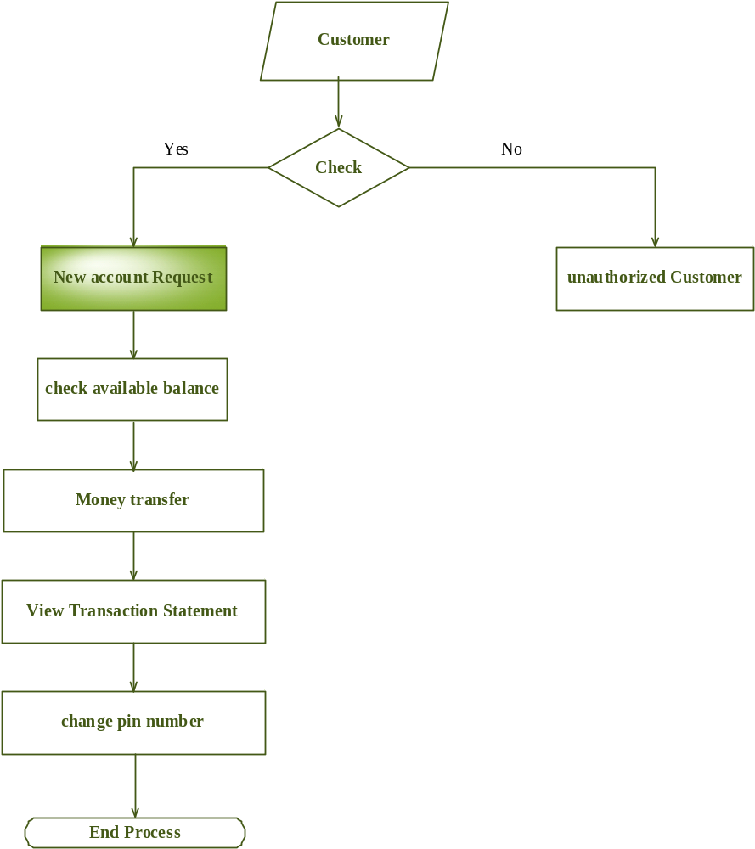

User Case Diagram
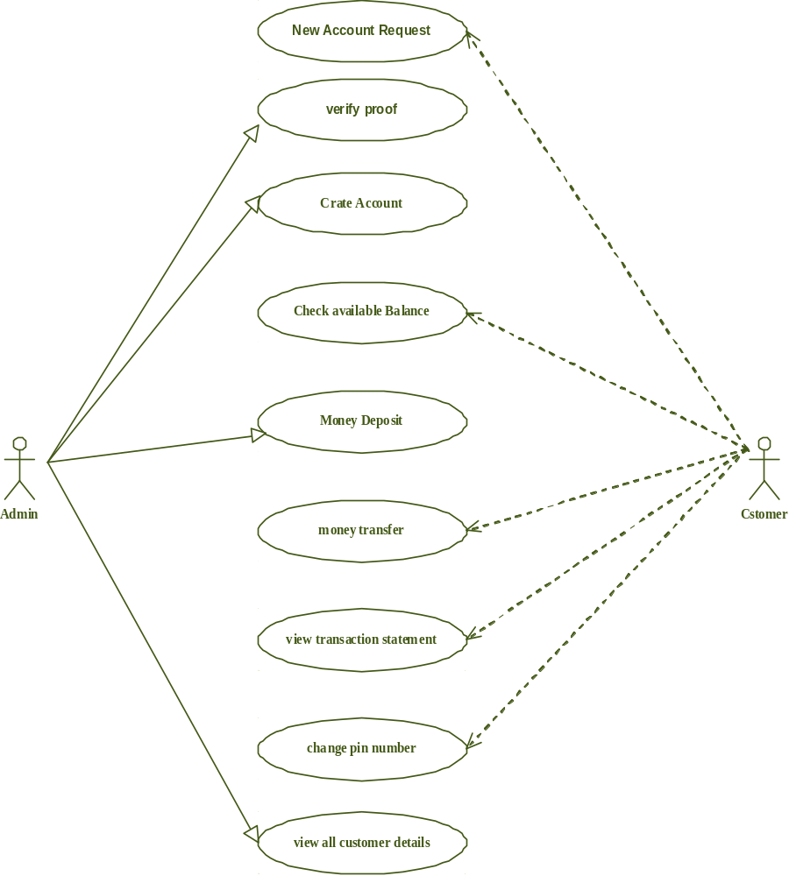

Class Diagram
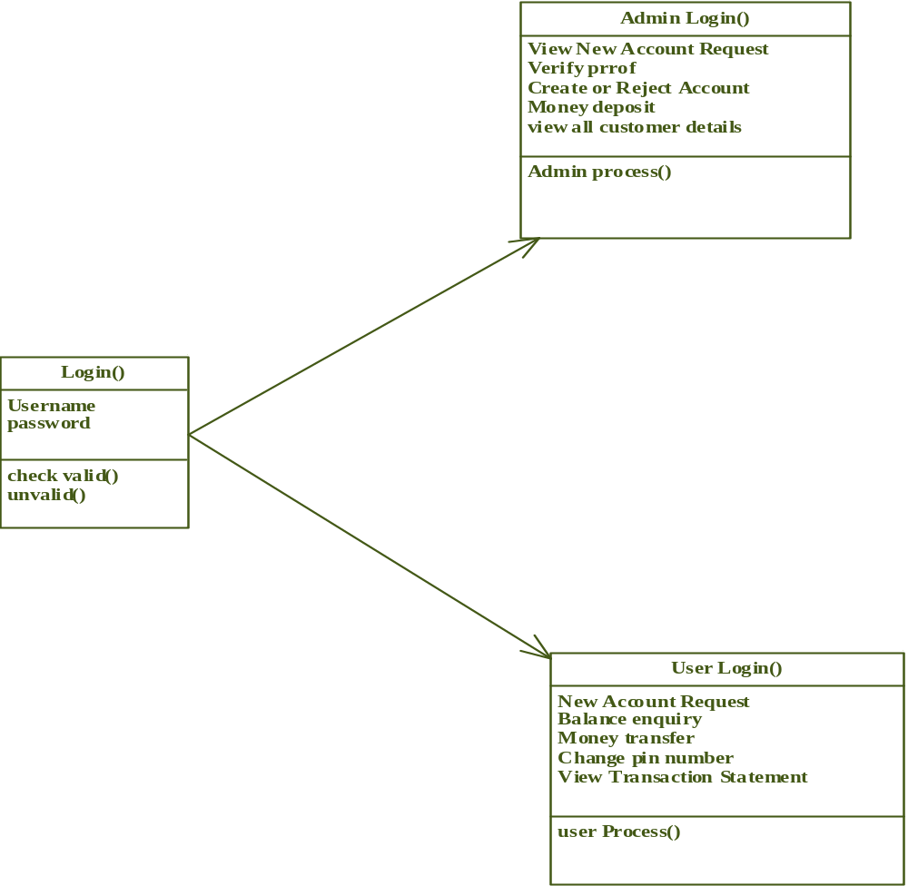

Activity Diagram
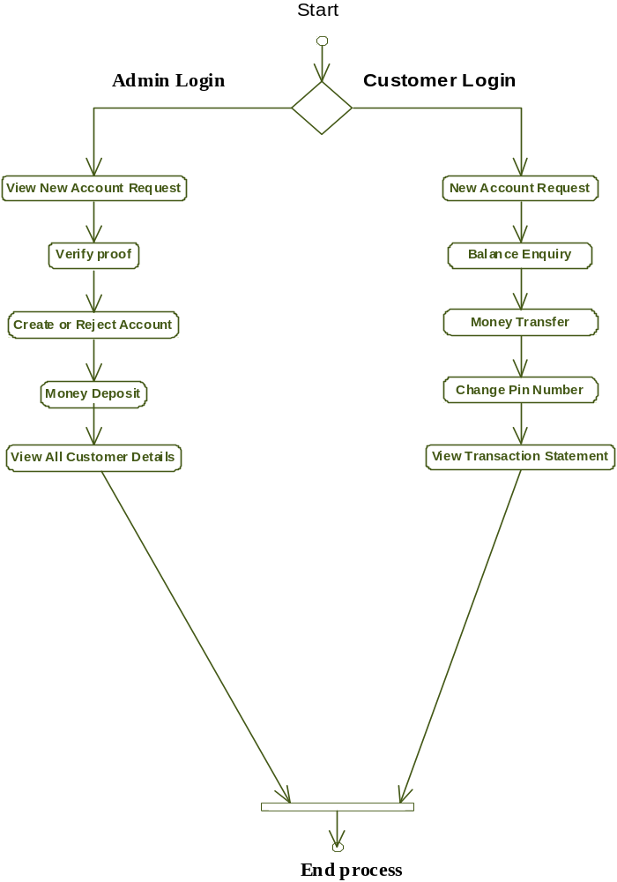

Sequence Diagram
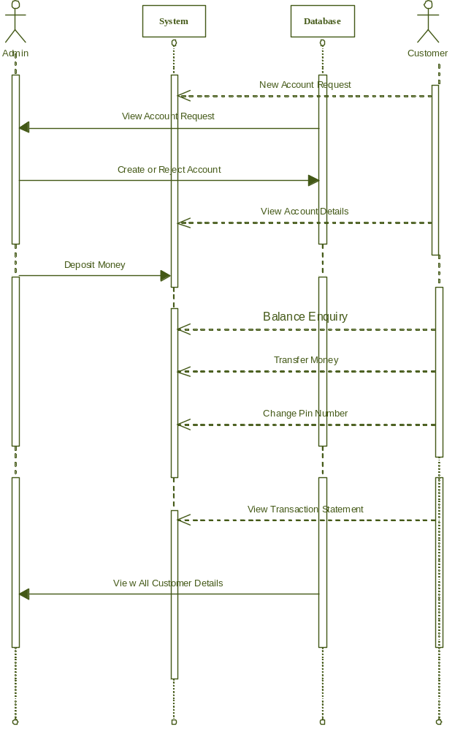

NON-FUNCTIONAL REQUIREMENTS:
Software requirements:

Operating System : Windows
Technology : Java and J2EE
Web Technologies : Html, JavaScript, CSS
Web Server : Tomcat
Database : My SQL
Java Version : J2SDK1.5

Hardware requirements:

Hardware - Pentium
Speed - 1.1 Ghz
RAM - 1GB
Hard Disk - 20 GB
Floppy Drive - 1.44 MB
Key Board - Standard Windows Keyboard
Mouse - Two or Three Button Mouse
Monitor - SVGA

9. ABOUT THE SOFTWARE

JAVA:
Java is used as front-end tool for developing the project. To run Java there is no need to have any particular operating system, as it is platform independent. This must have certain hardware and software installed on your computer. The key considerations were summed up by the Java team in the following list of buzzwords:
- Simple
- Security
- Portability
- Object-oriented
- Robust
- Multithreaded
- Architecture-Neutral
- Interpreted
- High Performance
- Distributed
- Dynamic

THE JAVA 2 ENTERPRISE EDITION

The Java 2 Platform, Enterprise Edition (J2EE), has rapidly established a new programming model for developing distributed applications. This model is based on well-defined components that can automatically take advantage of sophisticated platform services. These components can be developed according to standard guidelines, combined into applications, deployed on a variety of compatible server products, and reused for maximum programmer productivity. This model is intended to both standardize and simplify the kind of distributed applications required for today's networked information economy.

J2EE Platform Benefits

With features designed to expedite the process of developing distributed applications, the J2EE platform offers several benefits:
- Simplified architecture and development
- Freedom of choice in servers, tools, and components
- Integration with existing information systems
- Scalability to meet demand variations
- Flexible security model

HYPER TEXT MARKUP LANGUAGE

HTML was specifically developed to use along with the Hyper Text Transfer Protocol (HTTP) to encode documents for display on the World Wide Web.HTML is defined in the HTML Standard, currently Version 4.0x. HTML standards are recommended by the World Wide Web Consortium, W3C. W3C also oversees the standardization of technologies related to the World Wide Web and publishes the HTTP (Hypertext Transfer Protocol) standards. HTML is initials for Hyper Text Markup Language. HTML is pronounced one letter at a time as if you are spelling the word HTML. It is not pronounced as "hit mill" and it is NOT a programming language. HTML cannot be used to write programs and it cannot control the precise layout of a web page. Web browsers are used to view HTML documents. Two popular web browsers are the Netscape Navigator 4.x and the Microsoft Internet Explorer 5.x. Browsers control the layout of a web page

JavaScript:

JavaScript enables you to embed commands in an HTML page. JavaScript is powerful and simple. HTML provides a good deal of flexibility to page authors, but HTML by itself is static; after being written, HTML documents can’t interact with the user other than by presenting hyperlinks. Scripting languages act as the glue that binds every thing together. JavaScript mainly provides a fairly complete set of built- in functions and commands, enabling you to perform math calculations, manipulates strings, play sounds, open new windows and new URLs, and access and verify input to your web forms.

JavaScript can also set the attributes, or properties, of web page elements and other objects present in the browser.

This way you can change the behavior of plugs–in or other objects without having to rewrite them. JavaScript commands

Macromedia Dreamweaver
- Macromedia Dreamweaver2.0 is one of the HTML Editor

- It also includes DHTML effects

- It is used to connect the forms to Servlets

- It is used to Hyperlinks the web pages

- It is used to create Templates

- It is used to attach Sound files and Animation files along with our Source.

The Java Server Pages (JSP):

Java Server Pages ™ technology is the Java ™ platform technology for building applications containing dynamic Web content such as HTML, DHTML, XHTML and XML. TheJavaServer Pages technology enables the authoring of Web pages that create dynamic content easily but with maximum power and flexibility.

Advantages:

- Write Once, Run Anywhere ™ properties
- High quality tool support
- Reuse of components and tag libraries
- Separation of dynamic and static content
- Support for scripting and actions
- Web access layer for N-tier enterprise application architecture(s)

JSP page:

A JSP page is a text-based document that describes how to process a request to create a response. The description intermixes template data with some dynamic actions and leverages on the Java Platform.The features in the JSP technology support a number of different paradigms for authoring of dynamic content. JSP pages can be used in combination with Servlets, HTTP, HTML, XML, Applets, JavaBeans components and Enterprise JavaBeans components to implement a broad variety of application architecture(s) or models.

- Maximum performance and scalability through its unique design with the Window’s multi-threaded architecture.
- Central and easy-to-use the Graphical User Interface (GUI).
- Automatic authentication of users by the Operating System.

ENTERPRISE JAVABEAN (EJB):

EJB is a standard server side component model for component transaction monitors. It automatically takes in to account many of the requirements of business systems-security, resourse pooling,persistence, concurrency and transasction integrity.

Overall goals

The Enterprise JavaBeans (EJB) architecture has the following goals:

- The Enterprise JavaBeans architecture will be the standard component architecture for building distributed object-oriented business applications in the Java programming language. The Enterprise JavaBeans architecture will make it possible to build distributed applications by combining components developed using tools from different vendors.

- The Enterprise JavaBeans architecture will make it easy to write applications. Application developers will not have to understand low-level transaction and state management details, multi-threading, connection pooling, and other complex low-level APIs.

- Enterprise JavaBeans applications will follow the “Write Once, Run Anywhere” philosophy of the Java programming language. An enterprise Bean can be developed once, and then deployed on multiple platforms without recompilation or source code modification.

- The Enterprise JavaBeans architecture will address the development, deployment and runtime aspects of an enterprise application’s life cycle.

- The Enterprise JavaBeans architecture will define the contracts that enable tools from multiple vendors to develop and deploy components that can inter operate at runtime.

- The Enterprise JavaBeans architecture will be compatible with existing server platforms. Vendors will be able to extend their existing products to support Enterprise JavaBeans.

- The Enterprise JavaBeans architecture will be compatible with other Java programming language APIs.

- The Enterprise JavaBeans architecture will provide interoperability between enterprise Beans and Java 2 Platform Enterprise Edition (J2EE) components as well as non-Java programming language applications.

- The Enterprise JavaBeans architecture will be compatible with the CORBA protocols.

Enterprise Bean Provider

The Enterprise Bean Provider is the producer of enterprise beans. The system output is an ejb-jar file that contains one or more enterprise beans. The Bean Provider is responsible for the Java classes that implement the enterprise bean’s business methods, the definition of the bean’s remote and home interfaces and the bean’s deployment descriptor.
The deployment descriptor includes the structural information of the enterprise bean and declares all the enterprise bean’s external dependencies.

Application Assembler

The Application Assembler combines enterprise beans into larger deployable application units. The input to the Application Assembler is one or more ejb-jar files produced by the Bean Provider(s). The Application Assembler outputs one or more ejb-jar files that contain the enterprise beans along with their application assembly instructions. The Application Assembler inserts the application assembly instructions into the deployment descriptors.
The Application Assembler can also combine enterprise beans with other types of application components (JSP) when composing an application. The EJB specification describes the case in which the application assembly step occurs before the deployment of the enterprise beans. However, the EJB architecture does not preclude the case that application assembly is performed after the deployment of all or some of the enterprise beans.

Deployer

The Deployer takes one or more ejb-jar files produced by a Bean Provider or Application Assembler and deploys the enterprise beans contained in the ejb-jar files in a specific operational environment. The operational environment includes a specific EJB Server and Container. The Deployer is an expert at a specific operational environment and is responsible for the deployment of enterprise Beans.The Deployer uses tools supplied by the EJB Container Provider to perform the deployment tasks. The deployment process is typically two-stage:

- The Deployer first generates the additional classes and interfaces that enable the container to manage the enterprise beans at runtime. These classes are container-specific.
- The Deployer performs the actual installation of the enterprise beans and the additional classes and interfaces into the EJB Container.

EJB Server Provider

The EJB Server Provider is a specialist in the area of distributed transaction management, distributed objects, and other lower-level system-level services. A typical EJB Server Provider is an OS vendor, middleware vendor, or database vendor. The current EJB architecture assumes that the EJB Server Provider and the EJB Container Provider roles are the same vendor. Therefore, it does not define any interface requirements for the EJB Server Provider.

EJB Container Provider:

The EJB Container Provider provides:

• The deployment tools necessary for the deployment of enterprise beans.
• The runtime support for the deployed enterprise bean instances.

The focus of a Container Provider is on the development of a scalable, secure, transaction-enabled container that is integrated with an EJB Server. The Container Provider insulates the enterprise Bean from the specifics of an underlying EJB Server by providing a simple, standard API between the enterprise Bean and the container. This API is the Enterprise JavaBeans
component contract. The Container Provider typically provides support for versioning the installed enterprise Bean components.The Container Provider typically provides tools that allow the system administrator to monitor manage the container and the Beans running in the container at runtime.

Persistence Manager Provider

The Persistence Manager interacts with the Container to receive notifications related to the lifecycle of the managed beans. The current EJB architecture, however, does not architect the full set of SPIs between the Container and the Persistence Manager. These interfaces are currently left to the Container Provider and Persistence Manager Provider.

System Administrator

The System Administrator is responsible for the configuration and administration of the enterprise’s computing and networking infrastructure that includes the EJB Server and Container. The System Administrator is also responsible for overseeing the wellbeing of the deployed enterprise beans applications at runtime.

Database Independency
This ensures that the data is independent of the application. The application program must be independent of the database. If this is ensured, then the application can be modified in the future without any change to the database. This change also doesn’t affect the other application in the system. Similarly a change made to the database does not affect any programs if data independence is ensured. This database independency is satisfied by the current system..

10. SYSTEM TESTING & IMPLEMENTATION

System Testing:

The system once finished has to go through a series of testing in order to ensure that it works the way it ought to. The various types of testing measures to be taken are:

- Test to see if the requirements are taken care of.
- Test to see if all the inputs are handled effectively.
- Test the system by traversing all the paths and discover my surprises.
- Check if errors and the exceptions have been handled properly.
- See if validations of input data are taken care of.

Types of Tests:

There are six types of test a software product must satisfy:

- Unit Test
- Functional Test
- Performance Test
- Stress Test and
- Structural Test
- System Test

Functional Test, Performance Test and Stress Test are known as Black box testing. Structural Test is referred as White box or Glass Box testing.

1. Unit Testing:

Unit testing focuses verification effort on the smallest unit of software design. Unit Testing is considered as an equivalent to coding step. After the source level code has been developed, reviewed and verified for correct syntax, unit test case design begins. In most of the applications, a driver is nothing more than a main program that accepts test case data, passes such data to the module to be tested and prints the relevant results.
2. Functional Testing:

Functional Testing involves testing the system under typical operating condition, typical input values and for typical expected results. The functional boundaries specifies boundary within which the system can function. three types of functional tests are done

    - Checking the documented functions.
    - Checking with maximum values.
    - Checking with valid input.

3. Performance Testing:

Performance Testing is conducted to identify the bottlenecks in the system and to fine-tune the overall performance of the system.

4. Stress Testing:
Stress Testing involves overloading the system in various ways and observing the behavior.
The system is tested with high network traffic and more number of clients. Stress test provides valuable insight about the strengths and weakness of a system.

5. Structural Testing:

Structural Testing are concerned with examining the internal processing logic of a program and traversing particular execution paths.

6. System Testing:

System Testing involves two kinds of activities
1. Integration Testing and
2. Acceptance Testing
1. Integration Testing:

Integrating all the functionalities since some functions work perfectly when run alone tests the system.

Integration Testing is of two types
- Top down Integration Testing and
- Bottom-Up Integration testing.

- Top down Integration Testing:

In Top down Integration the top of the hierarchy is tested then one or
two immediately subordinate routines are tested.

- Bottom-Up Integration Testing:

First the modules at the very bottom, which have no subordinates, are tested then
these are combined with higher-level modules for testing.

2. Acceptance Testing:

Acceptance Testing involves planning and execution of functional tests, performance tests and stress tests in order to demonstrate that the implemented system satisfies its requirements.

QUALITY ASSURANCE

The aim of this step is to maintain or to ensure the quality of the system developed. The quality assurance goals in the system life cycle involves

1. Quality factors specification: - This was done to determine the factors that
Lead to high quality of a system.

Correctness- The extent to which a program meets system specification.

Reliability – The degree to which a program meets system specification.

Efficiency - The amount of computer resources required by the entire program
to perform a function.

Usability – The effort required learning and operating the system.

Maintainability – The ease with which the program errors are located
and corrected.

Testability - The effort required to test a program to ensure its
Correct performance.

Portability – The ease of transporting a program from one hardware
configuration to another.

Accuracy - The required precision in input editing, computation and output.

Error Tolerance – Error detection and correction versus error avoidance.

Expandability - Ease of adding or expanding existing databases.

Access Controls and Audit – Control of access to the system and the extent
to which that access can be audited.

l. Communication – How useful the input and output of the system are.

1. Software Requirements Specification: - This was done to generate the required documents that provide the technical specification for the design and development of the software.

2. Software Design Specification: - This was done in order to provide the functions and features described in the previous stage.

3. Software Testing and Implementation: - This was done to provide necessary software adjustment for the system to continue to comply with the original specifications.

Quality Assurance is the review of software and related documentation for correctness, accuracy, maintainability, reliability, and expendability. This also includes assurances that the system meets the specifications and requirements for its intended use performance.

11. IMPLEMENTATION:

The above said testing can be done virtually. In order to implement the VB .Net for Knowledge Based Decision Support System. Implementation includes all those activities that take place to convert from an old system to a new one.
Three aspects of implementation are:
1. Training Personnel
2. Conversion
3. PointImplementationReview

Training System Operators:

The training ensured that they were able to handle all possible operations, both routine and extraordinary. Training also involved run procedures, which involves working through the sequence of activities needed to use a new system on an ongoing basis.

12. CONVERSION:

Conversion is the process of changing from an old system to a new one. There are basically four conversion methods:
- Parallel Systems-offers greatest security.
- Direct Cutover- Presents the highest risk.
- Pilot Approach
- Phase-Inmethod

The approach followed for implementing the system was the Pilot Approach. The working version of the system was implemented in one regional office, so that the employees were aware that they were piloting a new system and that changes could be made to improve the system.
The system would be installed throughout the organization using the phase in methods. This approach had the advantage of providing a sound training ground before full implementation.
Post Implementation Review:

After the system is implemented and conversion is complete, review of the system is usually conducted by users and analysts alike. It is important to determine whether the system is working, how it has been accepted and whether adjustments are needed. The review is also important to gather information for the maintenance of the system.

Review Questions: - The most fundamental concern during the post implementation review is determining whether the system has met its objective, that is analysts want to know whether the performance level of users has improved and if the system is producing the result intended.

Conclusion

The new customer must upload their proof like voter id, driving license. After submitting all information the bank administrator verify the information. If the details given by the customer are correct the admin create a account else reject their application. The customer check their balance and can change their security pin number. The administrator deposit money to corresponding customer. The customer can transfer money to any person’s account. The customer can view statement of all transaction. The money deposits made by the bank administrator to the corresponding customer.

ONLINE RESOURCES
www.jsptags.com
www.java.sun.com/products/jsp/resources.html
www.roseindia.net
www.softlandindia.com/java.html

